**Introduction of ADC and DAC**

1. A digital quantity will have a value that is specified as one of two possibilities such as 0 or 1.
2. Most physical variables are analog in nature and can take on any value within a continuous range of values.
3. A transducer is a device that converts the physical variable to an electrical variable.
4. The transducer’s electrical analog output serves as the analog input to the ADC. The ADC converts this analog input to a digital output.
5. This digital output from the computer is connected to a DAC, which converts it to a proportional analog voltage or current.

**ADC Interfacing Diagram**

The ADC 0808 is 8-channel 8-bit ADC chip. It has 8 analog inputs i.e. IN0-IN7.

One of these channels is selected by sending address to a address line of ADC.

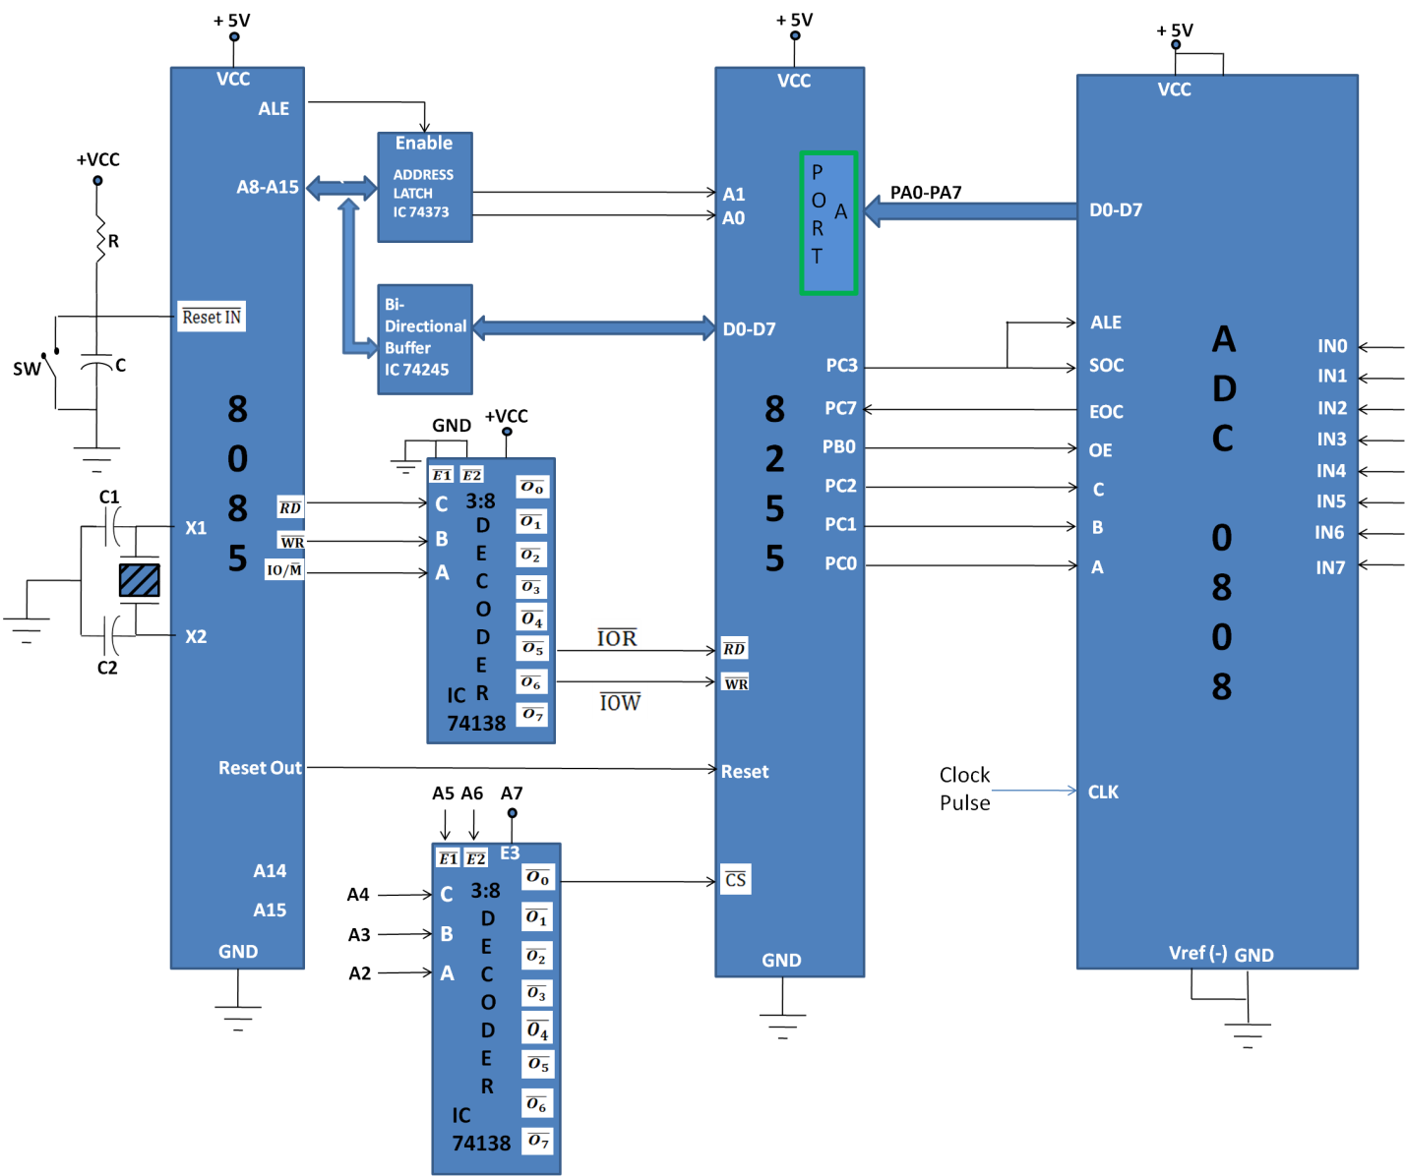

The digital equivalent data D0-D7 is connected to PA0-PA7 of Port A.

The PC0, PC1 and PC2 lines of Port C are connected to channel select address lines of 8255.

PC3 is connected to SOC (Start of conversion) and ALE signal (Input signal). EOC (End of conversion) which is an output signal of 8255 connected to PC7 of Port C.

The PB0 of Port B is connected to OE (Output Enable) input signal of ADC.

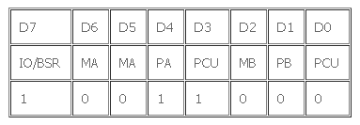

A high to low signal is applied for obtaining data from ADC .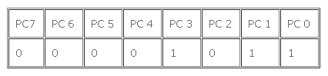0BH(SOC high)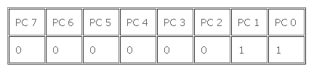03H(SOC low)

OE(Output Enable):

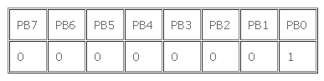01H(OE)

## Program/Code

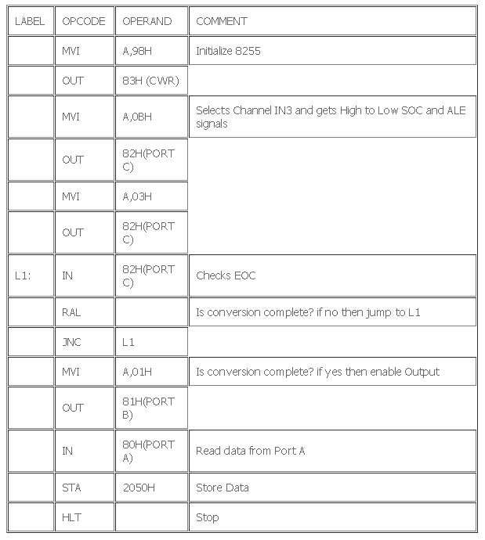

**DAC Interfacing with 8085 Microprocessor**

To convert the digital signal to analog signal a Digital-to-Analog Converter (DAC) has to be employed.

✓ The DAC will accept a digital (binary) input and convert to analog voltage or current.

✓ Every DAC will have "n" input lines and an analog output.

✓ The DAC require a reference analog voltage (Vref) or current (Iref) source.

✓ The smallest possible analog value that can be represented by the n-bit binary code is called resolution.

**Square Wave Generation Using DAC 0800**

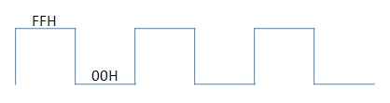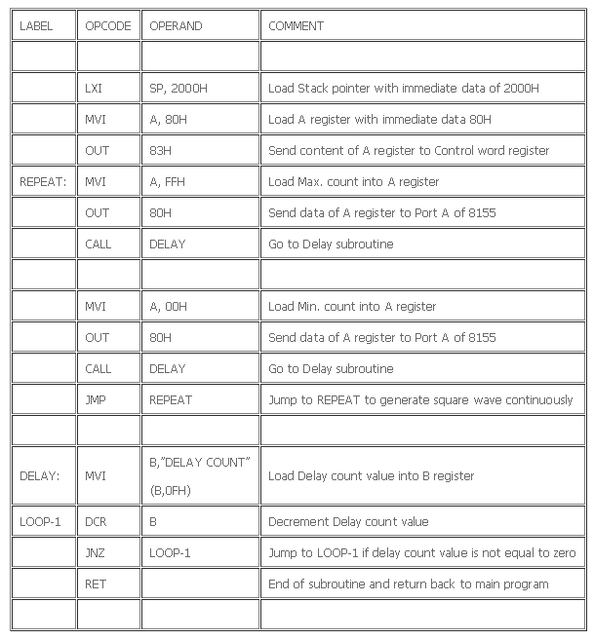

**Triangular Wave Generation Using DAC 0800**

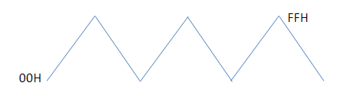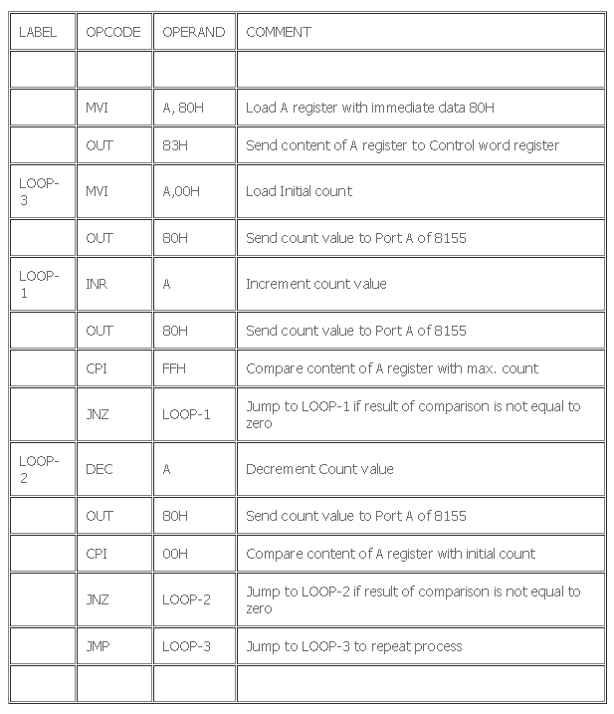 KINDLY CHANGE DEC BY DCR IN THIS PROGRAMME.